**Programming Fundamentals 3**

Danny O’Leary, Daniel Ivers, Jamie Doyle, Adam O’Reilly

16th – 22nd March

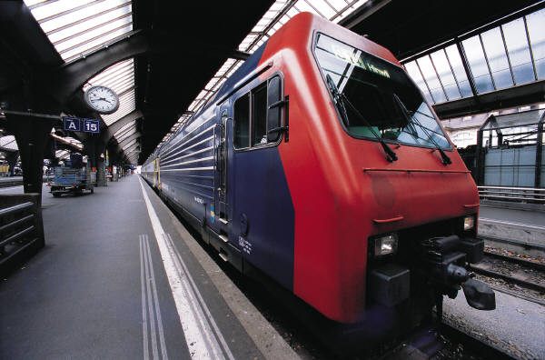

Week 2 of PBL Assignment - Timesheet

**What needed to be done?**

1. Save /load issue needed to be fixed.
2. Game has flaws that locks player out, or does not do what it is supposed to.
3. Add a rules section.
4. Decide if a GUI was doable.
5. Review code and see if little tidy up improvements could be made before submission.

**Save/Load**

* Our save/load function was a problem and was not working. There was discussions to leave it out as it was time consuming, after some discussion Danny decided to do some research on it, and found a good way to do it, and once he understood how it worked, he tried it out and it worked.

**Game flaws**

* Our game had a lot of flaws that needed fixing, if a player pressed the wrong button, the game wouldn’t react the way we wanted it to, Adam tested the game manually a lot, to find these little errors that could be patched up.

**Rules**

* Everybody agreed it would be a good idea to add a rules section in one of the menus to help the players understand the game, or refresh their memory while playing. Daniel provided this easy task.

**GUI**

* We had to make a decision was a GUI on the cards, as time was running out and the possibilities of one being accomplished looked out of reach, we decided to scrap the idea.

**Review of code**

* The last thing we did, was just look over the code and see could we improve it in anyway, little bits of validation were added here and there to make sure the user could play the game efficiently.